CLIDIVE BSAC 410 DIVE & BOAT LOG  LOOSE EQUIPMENT CHECK LIST:  FUEL BOAT BOXES OARS EPIRB  OIL ‘A’ FLAG HAND HELD RADIO THROW ROPE  SHOT OXYGEN WATER BOAT KNIFE  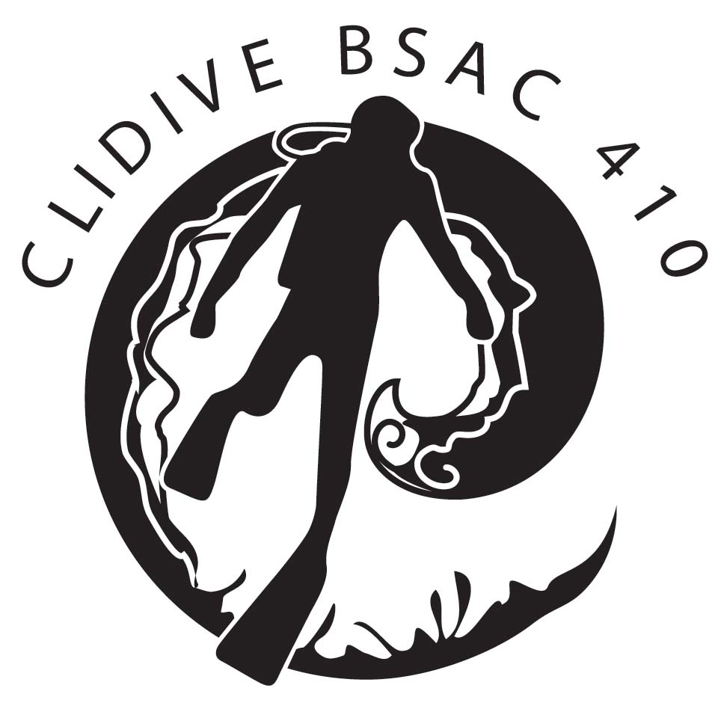  Date  Site  Latitude  Longitude  Boat  Cox’n  Sea State  HW / LW Times  NAME | DIVER  GRADE | O2% | MOD | AIR  IN | DIVE  PLAN  TIME | TIME  IN | TIME  OUT | AIR  OUT | MAX DEPTH | TOTAL DIVE  TIME | DECO TIME

VHF LOG
TIME DETAILS
EMERGENCY CONTACT NUMBERS:
COASTGUARD Channel 16 and 999
ENGLAND & WALES HELPLINE 07831 151523
SCOTLAND HELPLINE 0845 408 6008
DDRC 01752 209999
POOLE HYPERBARIC CENTRE 01202 678278

Notes:

